Transcriptome based Endometrial Receptivity Assessment (TERA)
Patient name | : | Mrs. | PIN | :
Date of Birth/ Age | : | Years | Sample Number | :
Referring Clinician | : | Dr. | Cycle type | : | HRT; P+5
Hospital/Clinic | : |  | First P4 intake date | : | 09-01-2025 10:30 Hrs
Specimen | : | Endometrial Biopsy- 1 | Biopsy date | : | 14-01-2025 14:05 Hrs
Specimen receipt date | : |  | Report date | :

Endometrial receptivity status

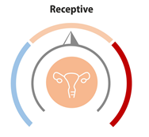
The gene expression profile of the endometrial biopsy sample performed on P+124 Hrs is indicative of a receptive endometrium

Recommendations for personalized Embryo Transfer (pET)

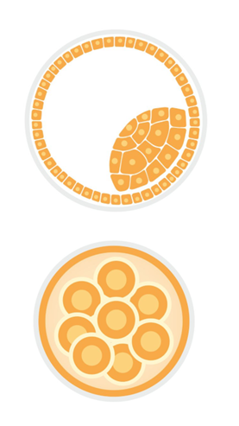
Blastocyst transfer (Day 5/6 embryo): 124 + 2 hrs post first progesterone intake

Cleavage stage transfer (Day 3 embryo): 76 + 2 hrs post first progesterone intake

Interpretation of results

Endometrial transcriptome analysis is indicative of an endometrium that is receptive and therefore represents a window of implantation.
A blastocyst transfer (Day 5/6 embryo) is recommended to be performed in the same type of cycle (HRT) at 124 ± 2 hrs post first progesterone administration.
A cleavage stage transfer (Day 3) is recommended to be performed in the same type of cycle (HRT), 2 days earlier at 76 + 2 hrs post first progesterone administration.

About TERA
Embryo implantation is a highly organized process during which the embryo attaches to the surface of the endometrium. Synchronous structural and functional remodelling of the uterine endometrium and the blastocyst is essential for successful implantation. The window of implantation (WOI) is a limited time span during which crosstalk between a receptive uterine endometrium and a competent blastocyst occurs effectively
A displacement in the window of implantation is among the leading causes of recurrent implantation failure and is observed in 30% of women undergoing ART conception. It is frequently observed that an endometrium that appears morphologically ready for implantation may not express appropriate transcriptomic response characteristic of WOI. Therefore, an accurate molecular description of the endometrial transcriptomic signature is essential in ensuring implantation of embryos with good development potentials.
TERA is designed to provide personalized embryo implantation time on the basis cutting-edge technical expertise based on Next generation Sequencing (NGS) that allows us to study unique endometrial signature representation of WOI. Highest reproducibility in TERA results is observed in HRT cycles.

Methodology

TERA detects mRNA expression in endometrial tissues using NGS based RNA-seq method combined with Artificial Intelligence (AI) empowered data analysis platform to discern endometrial status. The results are used as references for embryo transfer to improve chances of successful implantation.
- The duration of WOI may vary from patient to patient. The results of this test suggest the optimal time to transfer embryos and enable accurate clinical recommendations for embryo transfer.

References
- Achache H, Revel A. Hum Reprod Update, 2006, 12(6):731-46.
- Teh W T, Mcbain J, Rogers P. Journal of Assisted Reproduction & Genetics, 2016, 33(11):1-12.
- Mahajan N. Journal of Human Reproductive Sciences, 2015, 8(3):121-129.
- Ruiz-Alonso M , Blesa D , Díaz-Gimeno, Patricia, et al. Fertility and Sterility, 2013, 100(3):818-824.

This report has been reviewed and approved by:

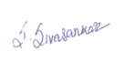 |  | 
S. Sivasankar, Ph. D | Fiona D’Souza, Ph. D | Sachin D Honguntikar, Ph. D
Molecular Biologist | Head -Scientific Operations | Head- Clinical Genetics

